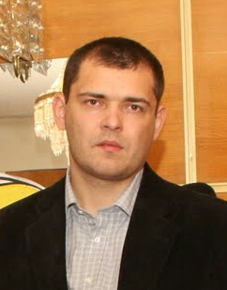Pavel Manger

Age: 33

Tel:+38(093)6009759

Email:[mangerpavel@gmail.com](mailto:mangerpavel@gmail.com)

skype: klimatinua

Junior QA Engineer

|  |  |  |
| --- | --- | --- |
| EXPERIENCEEngineer Cisco main office bank “Oschadbank”  2014 – 2017  Fixing and finding failures 24 regions and main office bank’s network  **Responsibilities :**   * Troubleshooting all networks problems * Analysis ticket from other departments * Defects documentation * Work with documentation Cisco  Private firm <Manger P.V> Director  2007 – 2014  Sale heating equipment trade in heating appliances  **Responsibilities :**   * Analytics * Work with documentation equipment * Control all creation stages of two Company Websites.   Company<Stamar> ( Sale heating equipment)  Sales manager  2005 – 2007 |  | SKILLS  * QA terms and SDLC * Creature test-cases, test plan * Requirement analysis * Agile(Scrum) * Bug report in bug tracker JIRA * Functional testing, Regression testing * Basic knowledge Git, Selenium IDE, Webdriver, Jmeter with Badboy, firebug/firepath, Spoon, xmind, fiddler * basic knowledge HTML, SQL, OOP(C#) * Client-Server architecture * knowledge networks, protocols HTTP, TCP/IP,FTP * VM, Windows, Ubuntu  EDUCATIONCourses QA Engineer, HTML, SQL http://skillup.com.ua –Кiev, Ukraine  2016 -2017 Online courses QA http://testbase.ru/learn  2016 courses basic OOP, GIT http://geekbrains.ru  2016 NATIONAL UNIVERSITY OF FOOD TECHNOLOGIES (with honors) Faculty of Automation and Computer Systems  Kiev, Ukraine  2002-2005 Kiev Energy College (with honors) Faculty of Automation thermal energy processes  Кiev, Ukraine  1998-2002 LANGUAGE English – limited working proficiency (reading and translation technical documentation, writing letters, elementary speaking) |